**Third Annual**

**Davis - Thompson Foundation**

**Eastern European Veterinary Pathology**

**Meeting**

**Hotel Sileks, Ohrid, North Macedonia**

**25-27 May 2022**

Prices for accommodation: Double room Single room______

Hotel Sileks**** **43 EUR**/per person **53 EUR**/per person

* prices are for FB per night (room, breakfast, lunch and dinner)

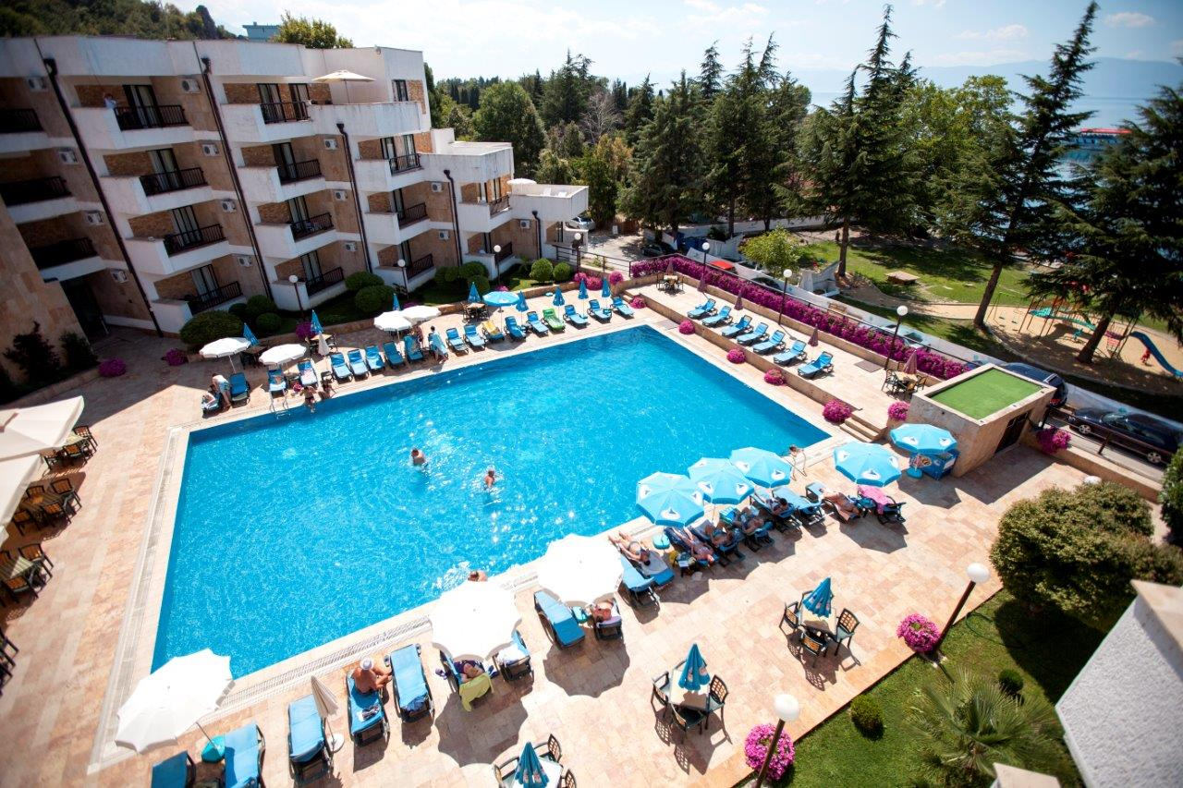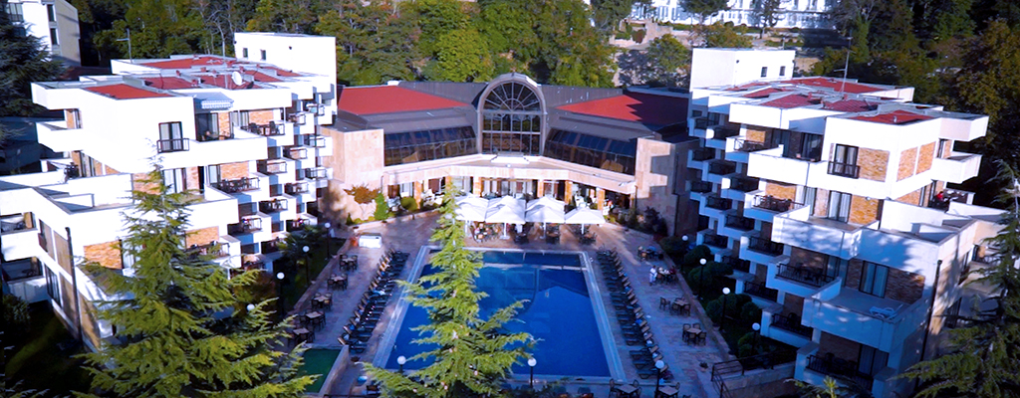

**RESERVATION FORM:**

|  |  |
| --- | --- |
| **Days for stay** *(from-until)* |  |
| **Type of room**  *(single room / double room)* |  |
| **Name of the quest** |  |
| Name of the second quest  *(only for double room)* |  |
| **Company** |  |
| **Contact**  *(telephone number / e-mail)* |  |

Payment: 1) at the hotel Reception 2) by pro forma invoice

Please send the reservation form to the hotel Sileks reservation department:

e-mail: info@hotelsileks.mk

tel.no: 046 277 300

fax. no: 046 277 304

[www.hotelsileks.mk](http://www.hotelsileks.mk)

**The reservation is valid only with the confirmation from the hotel.**

**Reservation deadline 31st of March 2022.**